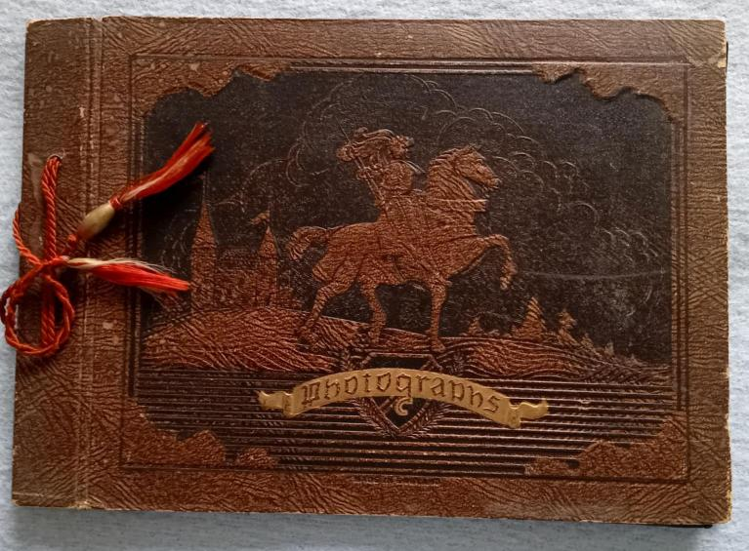

The photos in this section were digitised from an album held by Chris Yates.

It is believed that it was created by a landlord of *The Bell Inn* in the 1980s or 1990s, and consists of photos of Edlesborough, most of which have text provided, presumably by the person donating the photograph. Please note that the text is as it appears under original photograph so is the understanding of the author at the time.

Digitising the text means that they will appear in the results of any search, say of a persons name, date, etc.